Engineering Design Controlled Assessment
Name
Candidate number
Stocksbridge High School
Centre Number 36716

Contents:
- Mood Board
- Product analysis (Windows and Apple mouse)
- Product disassembly (Windows and Apple mouse)
- Engineered handles analysis
- Creative designs
- Product specification
- 2D designs
  - orthographic for each creative design
  - isometric for each creative design
- Product specification comparison

BRIEF

Background
A computer mouse is a pointing device (hand control) that detects two-dimensional motion on a surface. The primary function is usually to change the motion into the motion of a pointer on a display, which allows a smooth control of the information on the screen.
Physically, a mouse consists of an object held in one's hand, with one or more buttons. Mice often also feature other elements, such as touch surfaces and "wheels", which are secondary functions.
Minnie mouse Ltd are seeking to develop a new breed of ergonomic mouse. This type of mouse is intended to provide optimum comfort and avoid injuries such as carpal tunnel syndrome, arthritis and other repetitive strain injuries. It is designed to fit natural hand position and movements, to reduce discomfort.

Mood Board

Here you need to choose five images of different ergonomic mice and explain each one in terms of:
- What are the materials used?
- How the mouse is unique?
- How the mouse is suitable for specific users?
- Any good/ bad points about these mice?
- Any specific points about the aesthetics (colours or shapes) of the mice?

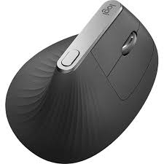
WAGOLL – This mouse has a more vertical shape than regular mice and has the click buttons on the side. This will enable people with limited vertical finger movement to control the mouse and therefore the computer functions. It has a sleek, curved shape which will enable it to be used by the user and also makes it unique and appealing to customers. The mouse as a circular plate on the base to enable it to stand upright and prevent it falling over.

Product analysis

Here you need to complete an ACCESS FM analysis of the Windows and Apple Mice. Use the sheet below and write paragraphs about each area shown. NOTE: To get a L2M or above, you need to write a summary comparison about the mice.
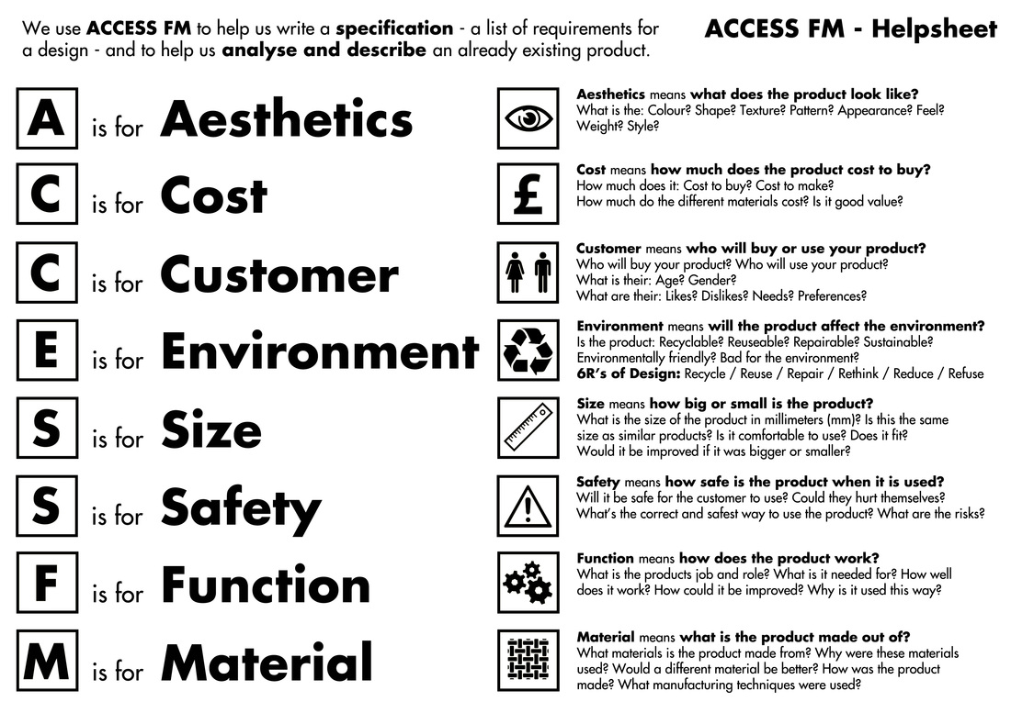
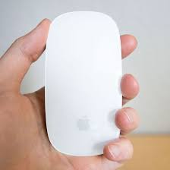
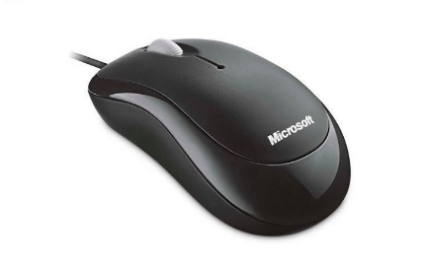

Product Disassembly

Here you need to identify each part of the Apple and Windows mice and explain, what materials it is made from and why these materials are used also describing what properties the materials have which make them suitable for use.

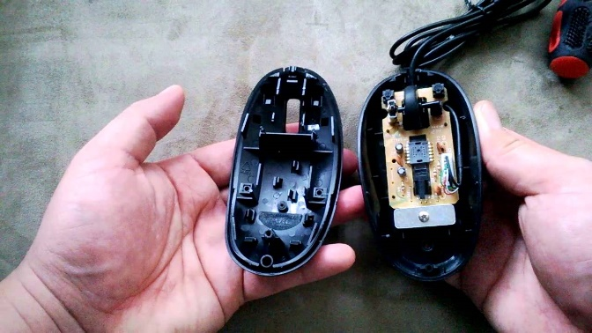
WAGOLL – The case of the mouse will be made from ABS plastic. This is because it can be easily moulded using injection moulding and will create secure fixings for the various components. The case is also rigid to withstand pressure and can be cleaned easily to avid contamination due to contact with the hands.

Engineered handles analysis

This section involves looking at different handles which exist already and identifying how they could be suitable for using as a computer mouse.

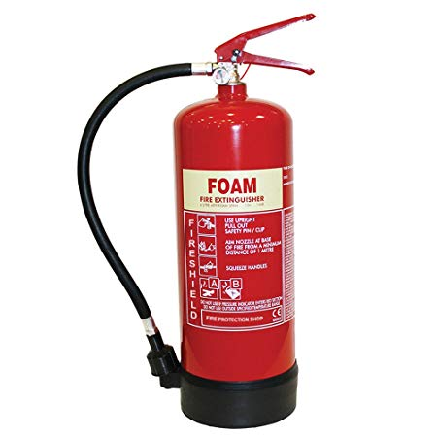
WAGOLL - The squeeze handle from the top of a fire extinguisher could be used on a computer mouse to control the extent of movement of the cursor. This would enable people who could not have the fine pressure of clicking a mouse to squeeze with the whole hand and move around the screen based on twisting the handle from a fixed central point. The product would be made from ABS plastic as this is a rigid material and can be easily cleaned as it involves regular contact with the hands. The two areas of the handle could be coloured different bright colours such as red and yellow which would enable these to be recognised by people with disability issues also.

Creative designs

This section includes different creative designs based on the handles analysis in the previous section to be adapted into ergonomic mice. Each design needs to be annotated to explain the reasons for use and the product based on as well as the materials each component is made from and why these have been chosen.

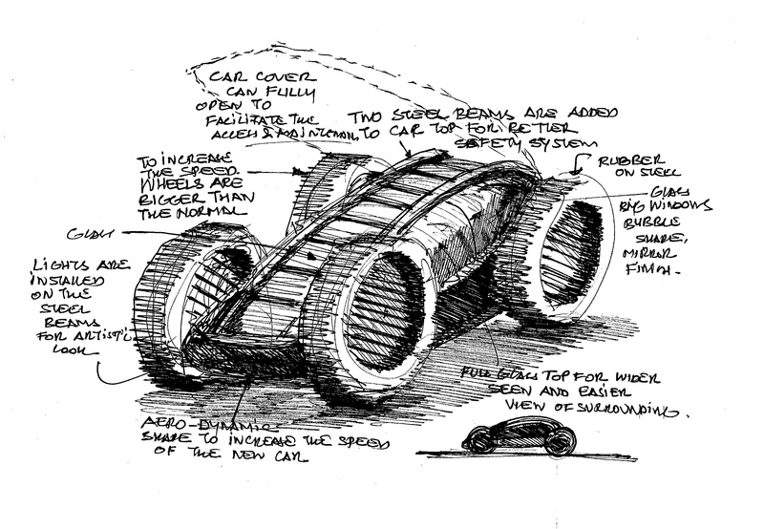
WAGOLL

Product Specification

This is a list of bullet points which show criteria that the products should be. There should be at least 10 bullet points which cover a range of areas identified in the earlier ACCESS FM for your ideas to be compared to later.

e.g.
- The product will be … (colour).
- The product will be aimed at … (teenagers/ designers/ elderly/ people with arthritis)
- The product will be … (size)
- The product will cost … due to …
- The product will be made from …
- The product will be safe as …
- The product will be recyclable as …
- The product will … (function)
- The product will be made … (manufacture)
- The product will be controlled by …

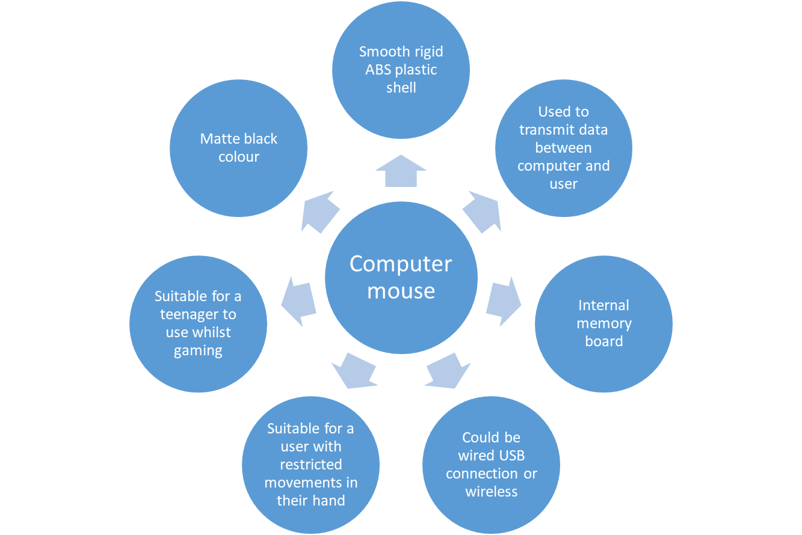

2D design orthographic drawings

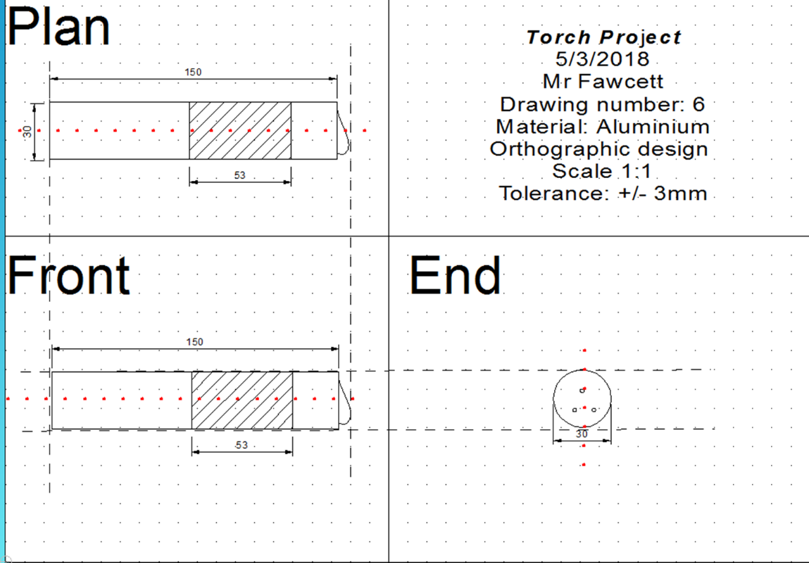
2D design Isometric drawings

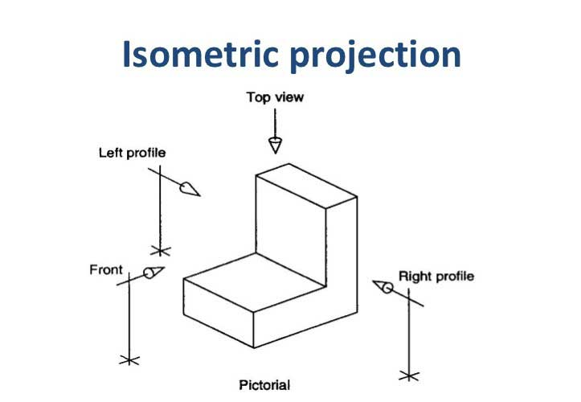

Product specification comparison

This section involves copying and pasting the original specification and relating each point specifically to the creative design.

E.g.
- The product will be … (colour).
The fire extinguisher mouse is red and yellow colour which will enable it to be seen by users with visual impairments and will be brightly coloured to attract consumers in the first place.
The gearstick mouse will be matte black coloured which will enable it to have a sleek design and will be attractive to the teenage market.
The steering wheel mouse will be a gloss matte black colour which will attract consumers due to the shiny appearance and will be wipe clean allowing it to be safe due to preventing contamination.
- The product will be aimed at … (teenagers/ designers/ elderly/ people with arthritis)
- The product will be … (size)
- The product will cost … due to …
- The product will be made from …
- The product will be safe as …
- The product will be recyclable as …
- The product will … (function)
- The product will be made … (manufacture)
- The product will be controlled by …

