Minerva Learning Trust Term Time Leave Request
You may be aware that all school and Local Authorities have been issued with guidance from the government to restrict the amount of term time leave absence for students. Minerva Learning Trust has updated its attendance policy in line with these changes.
The updated government guidance states that no school will grant any notification for leave during term time unless there are exceptional circumstances. Holidays taken during term time will therefore not be authorised. Any parent/carer planning to take their child on a holiday during term time, are asked to still complete the term time leave request form found overleaf.
The policy allows the Local Authority to consider legal action in the case of any instance of unauthorised absence from school. Section 444 of the 1996 Education Act states that all parents have a legal obligation to ensure that their children attend school regulalry. Taking unauthorosed term time holidays and/or persistent absence may make parents/carers liable for a Penalty Notice (which is a fine). Details of the fines, which will be processesd by the relveant Local Authority, can be found below:
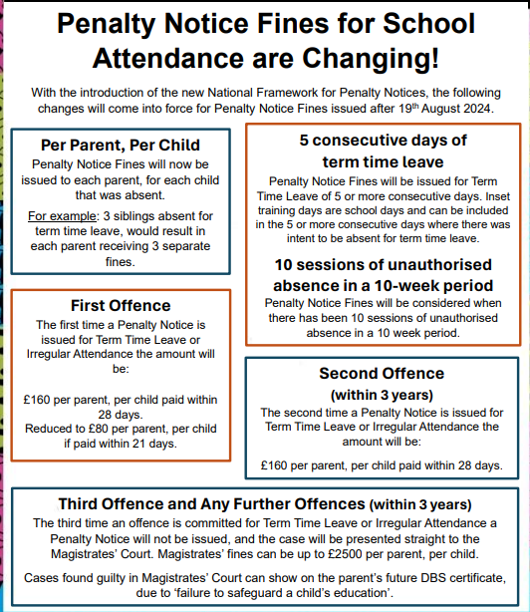

Term Time Leave Request Form
Name of pupil(s) at this school:  Information on sibling(s) in other schools:  (name, D.O.B, name of school)  Current address: | (please ensure school have correct details for all parents/carers)  Name of Parent/Carer 1:  D.O.B:  Name of Parent/Carer 2:  D.O.B:  Address of Parent/Carer 2 if different to that of Parent/Carer 1:
Dates of leave: From:
To:
Please provide detail below and the reason for the term time leave request:

- Exceptional leave during term time: Yes/No
(If yes, please provide and attach additional information/evidence to explain)

- Holiday in term time: Yes /No
Where will you be staying/visiting during the leave period?
If staying with friends/relatives, please provide the full address and Emergency Contact Details (UK and Abroad). If taking a holiday, please provide the region and country of travel.

UK:
Overseas:
I confirm that the information on this form is true.
I agree to keep the school informed of any changes to my travel arrangements or if my child is unable to return to school on the due date.
I am aware that if my child does not return to school by the date provided that he/she is at risk of losing their place at this school.
I am aware that I will be fined and/or prosecuted for any time which my child is absent from school that has not been authorised by the headteacher.
Signed by parent/carer: |  | Print name & relationship to child: | Date:
For school use only |  | Date request received:
Has the notification been considered by the Headteacher? Y/N
Has the notification been discussed with the parent/carer? Y/N Date:

No. of days Authorised:
No of days Unauthorised:

Date of decision letter sent to Parent/Carer:
If unauthorised leave is taken this case complies with Penalty Notice criteria, please forward to the Attendance Legal Team via Anycomm’s along with HTC, Pupil/Student attendance register.
Name of school: |  | Headteacher’s signature: | Date:

